AI-Powered Techniques for Automated Article Summarization to Enhance Information Retrieval

P Layavardhan
Artificial Intelligence and Data Science Department
Annamacharya Institute of Technology and Sciences
Rajampet, India
polisettylayavardhan1515@gmail.com
P Lokesh
Artificial Intelligence and Data Science Department
Annamacharya Institute of Technology and Sciences
Rajampet, India
lokesh.t2025@gmail.com
A Ahamad
Artificial Intelligence and Data Science Department
Annamacharya Institute of Technology and Sciences
Rajampet, India
aahamad2146@gmail.com
Mr. Y Venkata Subbaiah (Assistant professor)
Artificial Intelligence and Data Science Department
Annamacharya Institute of Technology and Sciences
Rajampet, India
venkatasubbaiah635@gmail.com
K Ram Charan
Artificial Intelligence and Data Science Department
Annamacharya Institute of Technology and Sciences
Rajampet, India
ramcharankondeti12@gmail.com

Abstract— This study offers a state-of-the-art method for automatically summarizing articles using Google's T5 (Text-To-Text Transfer Transformer) speech model. Using its cutting-edge design, T5 tackles the problem of producing succinct, logical, and contextually appropriate summaries from large text documents. We optimize T5 on a dedicated dataset to improve its summarization performance. We obtain remarkable results: ROUGE precise of 0.913, recall of 0.417, F1-score of 0.573, and BLEU score of 0.683. These metrics demonstrate how well the model captures the important information in articles while maintaining their core substance. Furthermore, we have used streamlit to provide an intuitive user interface that makes interacting with the summarizing system easy. With the help of this user interface, users may upload documents or enter text to get well-structured summaries instantly. The amalgamation of sophisticated artificial intelligence methodologies with a user-friendly interface manifests a noteworthy progression in the domains of data extraction and content management. This provides a beneficial resource for scholars, experts, and ordinary people who are in search of effective text summarization solutions.
Keywords— AI, Article Summarization, BLEU Score, Natural Language Processing, ROUGE Score, Streamlit UI, Text-to-Text Transfer Transformer and T5 Model.

Introduction
One of the most important tasks in Natural Language Processing (NLP) is text summarizing, which tries to condense the most important information from a document into a clear and short summary [1]. The procedure entails condensing a text while maintaining its essential concepts and significance. Conventional approaches to summarizing involve extractive strategies, which choose and group sentences from the original text, and abstractive strategies, which create new sentences that encapsulate the main ideas of the original material. The quality and efficacy of summarization have been greatly improved with the advent of sophisticated language models, especially those built on Transformer topologies, which allow for more complex comprehension and production of human language. The increasing amount of data in academia, the media, and industry [2] has led to a significant increase in the use of AI-powered summarization approaches in recent years. With the use of automated summarizing technologies, users may quickly and effectively scan lengthy texts for relevant information.
This feature is especially useful in settings like research, court papers, and news stories where prompt and precise information retrieval is essential. These technologies support increased productivity and well-informed decision-making in a variety of sectors by expediting understanding and decision-making. Our research focuses on utilizing Google's T5 (Text-To-Text Transfer Transformer) approach [3], a cutting-edge language model, to enhance automated text summarizing performance. The T5 model's architecture makes it extremely adaptable for summarizing by enabling it to handle a broad range of NLP tasks by structuring them as text-to-text challenges. We optimize T5 on a particular dataset to improve its summarization performance, and our tests show that T5 is effective based on performance measures like ROUGE and BLEU values [4].
These metrics show how well the algorithm is able to provide summaries that faithfully capture the original information. In addition to the technological developments, we have created an approachable user interface with streamlit, giving people a platform to engage with the summarizing system. With this interface, users may upload documents or enter text to generate real-time summaries. The practical applicability of our study is demonstrated by the combination of sophisticated AI algorithms with an easy-to-use interface, providing a useful tool for anybody in need of effective and efficient text summarization solutions [5]. This method meets the practical demand for expedited data analysis and retrieval while also advancing the field of robotic summarization.

literature survey
The majority of early text summary techniques were extractive in nature, meaning they selected important sentences or phrases from out of the original text. These strategies include graph-based algorithms [6], which find the most central sentences by modeling sentences as nodes in a graph, and frequency-based algorithms, which base a sentence's value on the frequency of important terms. Although these techniques were quite successful in locating pertinent material, they frequently had trouble creating descriptions that were both clear and succinct since they could only combine fragments of the original content without coming up with unique language. Day et al. proposed three models used in this study's proposed AI-based summarization of texts system are deep learning, machine learning, and statistics [7]. The deep learning model is trained by the system with essay titles and abstracts, and it produces brief summaries. ROUGE is used to assess these models' performance. Narayan et al. The presents a new challenge called "extreme summarization," which is generating a brief news summary using only one document. It makes the case that abstractive modeling is necessary and that extractive tactics are insufficient [8]. The researchers present an innovative abstractive model based on convolutional artificial neural networks after gathering a sizable dataset from the BBC.
A major change in summarizing technology was brought about with the introduction of abstractive summarization. Rather from just using preexisting phrases, abstractive approaches understand and rephrase the material to create summaries. Large datasets are used to train these models so they can comprehend the text's context and semantics and generate summaries that are more naturalistic and flowing than those written by humans [9]. Transformer-based models, such BERT and GPT, showed notable gains in summarization quality by utilizing attention processes to identify contextual information and long-range relationships. Sekaran et al. in order to facilitate human-computer interactions, the processing of natural languages [10] is a rapidly expanding field of study that combines linguistics, computer science, and artificial intelligence. In order to enable bots inventions to control physical equipment by speech-tagging, this research intends to construct gadgets that function on one person's command. Afantenos et al. reviews current efforts in medical document summarizing, emphasizing the increasing interest in medical and AI research because of the abundance of data accessible to academics and doctors [11]. A broad overview of document summary is given, along with a discussion of factors, assessment concerns, and several summarization methodologies.
Recent developments have used massive pre-trained language models, such as T5, to further enhance summarization approaches. Significant improvements in summary quality result from these models' fine-tuning for certain summarizing tasks once they are trained on a variety of datasets. Using these models' sophisticated summarizing skills has become simpler for non-experts because to their integration with user-friendly interfaces [12]. Thanks to these advancements, automated summarization may now be used to a wider range of tasks, including information retrieval, document analysis, and news aggregation. Neto et al. in order to extract characteristics from the original text, this work provides a summarizing technique employing trainable machine learning algorithms. The process makes use of linguistic and statistical elements that are taken from the condensed argumentative framework [13]. The outcomes are contrasted with standard summarizing techniques and utilized on popular text datasets. Ma et al. incorporating depth-wise differentiated convolution, attention mechanism, and time series system [14], this work provides a multi-scale semantic information Transformer (MSIT) for summarization of texts in IoT and edge computing, demonstrating improved performance on the CNN-Daily Mail Dataset.

DATA COLLECTION & PREPROCESSING

In the process of creating every kind of machine learning method, which includes those used for automatic text summarization, data gathering and preparation are essential processes (as shown in Fig.1). The first step in the procedure is to compile a large dataset that faithfully depicts the kind of content the model would come across in practical applications. This usually entails gathering a sizable number of written materials that span a variety of subjects and writing styles in order to complete summarizing duties. In order to enable supervised learning in which the model learns to produce summaries from given texts the dataset should ideally contain both the original writing and the summaries that correspond to them. The next crucial stage after gathering the dataset is preprocessing [15]. In order to make the raw data appropriate for training the summation model, this phase entails cleaning and preparing it. Among the preprocessing responsibilities are the removal of superfluous or unnecessary data, such as HTML elements, metadata, and any other content that doesn't aid in the summary process.
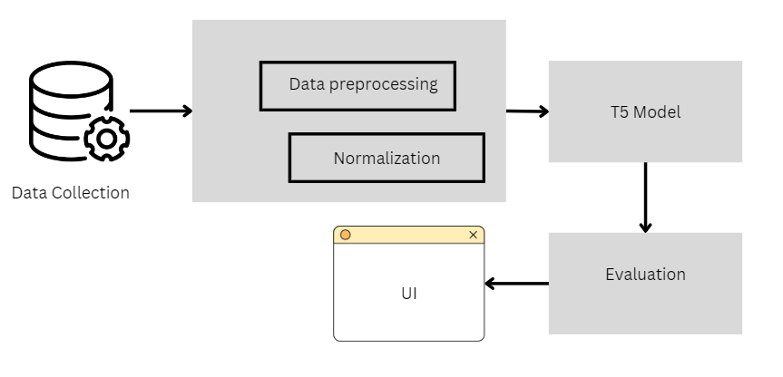
Fig.1 Architecture of the research
The objective is to ensure that the information being entered is as clean and pertinent as possible by concentrating just on the language elements that will be utilized to train the model. Normalization of text [16] is yet another crucial preprocessing step. This entails formatting the text in a consistent manner, usually by deleting special characters or punctuation that doesn't contribute to the summary work and lowercasing the entire text to maintain consistency. Furthermore, tokenization is carried out, in which text is divided into smaller pieces like words or sub-words, which serve as the fundamental building blocks for training the model. This is a critical step in converting unformatted material into a format that machine learning algorithms can interpret well. Preprocessing in the context of the T5 model, which performs text-to-text tasks, also entails transforming the incoming text into a format that the model can comprehend. This entails utilizing methods like token embeddings to encode the text into mathematical representations.
By mapping each token (word or sub-word) to a multidimensional vector space, token embeddings allow the model to efficiently analyze and produce text by capturing the semantic links between tokens. Techniques for data augmentation are frequently used to increase the number and variety of information used for training. These methods include back-translation, which involves translating a document into a different tongue and then back again, and paraphrase, which involves expressing the same information in multiple ways. These techniques assist in producing text variants that, by exposing the summarization model to various wording and structures, might increase its resilience. Preprocessing also includes handling partial or missing data. The model's performance may be affected by texts with portions missing or by incomplete summaries. To solve these problems and maintain the dataset's completeness and training utility, methods like imputation and data interpolation are employed.
The quality and dependability of the summation model depend on this stage. The dataset is usually divided into training, validation, and test sets after preprocessing. The set of validation variables is used to fine-tune model parameters and guard against overfitting, while the training set teaches the model how to produce summaries. The purpose of the test set is to assess the model's performance on data that hasn't been seen before, giving an idea of how well the model extends to new texts. To make sure that the model's performance indicators fairly represent its capacity to tackle summarization jobs in the actual world, this divide is essential. In order to reduce the discrepancy between its generated conclusions and the source summaries, the model modifies its internal parameters as it learns to map incoming texts to their respective summaries. Since well-prepared data frequently yields higher summarization results, the model's performance demonstrates the efficacy of the preprocessing stages. This thorough approach to data gathering and preprocessing establishes the groundwork for creating a summarization system that uses cutting-edge AI techniques and is both successful and efficient.

PRINCIPLES AND METHODS
The guiding ideas and techniques behind the creation of AI-powered text summarizing systems center on the use of cutting-edge machine learning structures and algorithms to produce clear, logical summaries from lengthy text sources. The employment of transformer-based models, including T5 (Text-To-Text Transfer Transformer), which have greatly improved the state of text summarization, is one of the fundamental ideas. The models in question are based on the structure of transformers presented by Vaswani et al., which handles long-range relationships in text by leveraging attention processes, allowing for the creation of high-quality highlights that preserve the original content's coherence and context. Transformers' fundamental idea is that they can dynamically determine the relative weights of various phrases or words in a document, which enables them to record complex connections.
In particular, the T5 model functions on the tenet that all NLP tasks should be framed as text-to-text challenges. Because both the input and the output are handled as text sequences, this makes it extremely flexible for a wide range of applications, including summarization. Using unsupervised learning techniques, the model is pre-trained on a large dataset to predict masked words in phrases and execute text creation tasks. By comparing the pre-trained model's output to the anticipated summaries for the supplied input texts, one may further hone the model's capacity to produce summaries on a particular summarizing dataset. This method guarantees that the model can provide concise, contextually appropriate summaries in addition to having a basic understanding of English. Text summarizing approaches incorporate various important strategies for improving the summarization model's performance, in addition to the fundamentals of transformer structures. Among these methods are attention mechanisms, which enable the model to generate each word of the summary by focusing on distinct portions of the input text.
The model is better able to prioritize pertinent information and disregard less significant details thanks to this dynamic attention, which produces a summary that are more cohesive and in line with the primary ideas of the original text. To further enhance the quality of the obtained summaries, beam search is frequently used in the decoding phase to produce a number of summary candidates and choose the one with the highest likelihood. Utilizing assessment metrics to evaluate the summarization model's performance is another crucial technique. The quality of produced summaries is typically measured using metrics like BLEU (Bilingual Evaluation Understudy) and ROUGE. ROUGE scores assess how effectively the model captures important information by comparing the relationship between the produced summary and reference reports and concentrating on accuracy, recall, and F1-score. The overlap of n-grams which are created and reference summaries, on the other hand, is measured by BLEU ratings, which offer information on the generated text's fluency and relevancy. Developers and investigators can enhance the model's accuracy and coherence to satisfy required criteria by utilizing these assessment metrics to fine-tune the model.

NLP TECHNIQUES

Text data is prepared and transformed using core Natural Language Processing (NLP) techniques including tokenization, stemming, and the lemmatization [17] so that it may be used for modeling and analysis (as shown in Fig.2). Every one of these methods has a specific function in text preparation and adds to the overall efficacy of NLP applications, including information retrieval, sentiment analysis, and text summarization. The first stage of text preparation is called tokenization, and it entails dividing a text into fragments known as tokens. Symbols, phrases, or words can be used as tokens, depending on the level of detail needed for the job. Tokenization's main objective is to transform an unending text stream into an organized format that can be processed by a machine learning model. One way to tokenize a statement like this is to break it down into individual words, like this: ["the", "quick", "brown", "fox", "jumps", "over", "the", "lazy", "dog"]. By making the text simpler, tokenization sets it up for next processing stages like eliminating stop words or using additional normalization methods.
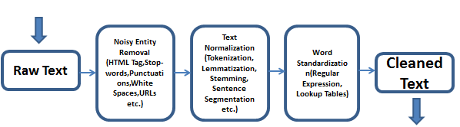
Fig.2 Pipeline of Text Preprocessing
The process of stemming reduces words to their stem, which is their base or root form. The goal of stemmed is to consider various word forms as one and the same thing by standardizing them. Words like "running," "runner," and "runs," for example, would all be simplified to their shared stem, "run." Heuristic principles are applied by stemming algorithms, such the Porter stemmer, to remove prefixes and suffixes from words, therefore standardizing the text and lowering dimensionality. Even though stemming [18] is useful for combining word variations, it can occasionally produce incomplete or non-standard stems that may not always express the meaning that was intended, particularly in languages with intricate morphological systems. Compared to stemming, lemmatization to is a more sophisticated process that reduces words to their dictionary-worthy canonical form, or lemma. Lemmatization reliably converts words into their basic forms using extensive linguistic vocabulary and knowledge databases, in contrast to stemming, which makes use of heuristic principles.
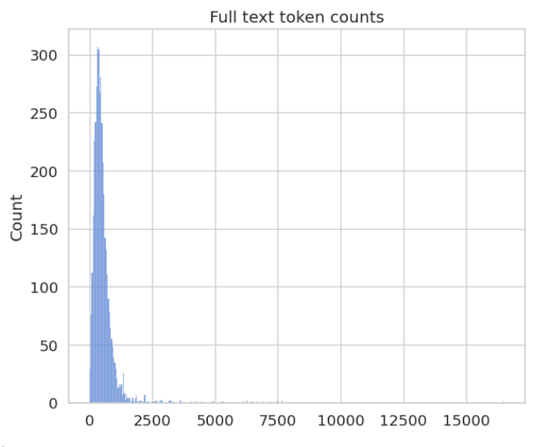
Fig.3 Full text token counts

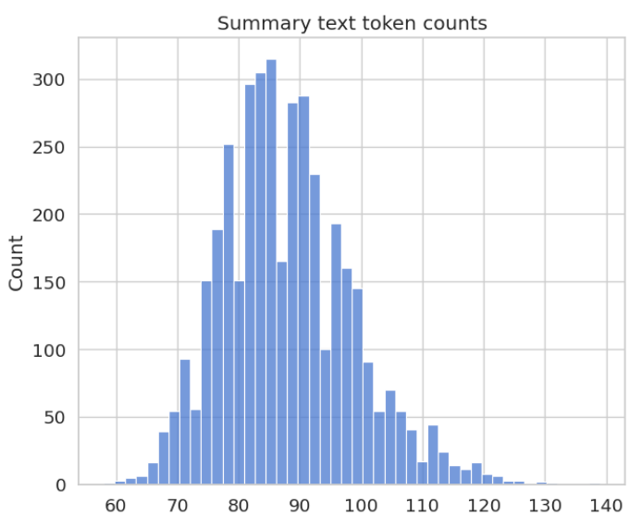
Fig.4 Summary text token counts
Lemmatization, for instance, would change "better" to "good," "running" to "run," and "geese" to "goose." Lemmatization guarantees that phrases are reduced to their correct forms, maintaining their meaning and enhancing the precision of text analysis by taking into account the word's part of speech and context. This method works especially well for high precision jobs like machine translation and text summarization. Text normalization techniques are essential for preparing text for natural language processing (NLP) tasks, including tokenization, stemming, and lemmatization. Normalization is the process of bringing material into a consistent format by addressing grammar, punctuation, and case variances. Normalization procedures sometimes involve fixing misspellings, eliminating punctuation that does not add to semantic meaning, and changing all text to lowercase to guarantee consistency. By standardizing the text and removing extraneous information, these preprocessing techniques make sure that the analysis concentrates on the important details.
To prepare text for natural language processing (NLP) tasks like tokenization, stemming, and lemmatization, text normalization techniques are crucial. The process of normalizing content involves correcting language, punctuation, and case variations in order to get it into a standard format. Correction of misspellings, removal of material that does not contribute to the content of the text, and conversion of all text to lowercase to ensure uniformity are examples of normalization methods. These preprocessing methods ensure that the analysis focuses on the crucial elements by normalizing the text and eliminating unnecessary information. To put it all together, text preparation methods like tokenization, stemming, lemmatization, and others are crucial for converting unstructured text into a format that can be analyzed. These techniques increase the performance of NLP models in a variety of applications by enabling them to handle and understand text data more efficiently. Researchers and practitioners may improve the quality of their analysis of text and create more dependable and accurate natural language processing (NLP) systems by comprehending and utilizing these strategies.

B. T5 MODEL
Google's T5 (Text-To-Text Transfer Transformer) approach [19] represents a noteworthy development in machine learning and natural language processing (NLP). It extends the Transformer architecture, first shown in the groundbreaking work "Attention is All You Need." T5's main novelty is its cohesive structure, which approaches each NLP problem as a text-to-text issue. Using a single, consistent architecture, this method makes training and fine-tuning algorithms for a variety of applications easier. Fundamentally, T5 makes use of the attention mechanism of the transformer architecture, which allows it to analyze and produce text by dynamically concentrating on various segments of the input sequence. By weighing each word or token's value in respect to others, the attention mechanism enables the model to capture distant dependencies and contextual linkages within the text. This skill is critical for jobs where comprehension of context and coherence are required, such question responding, translation, and text summary.
T5's pre-training on a sizable dataset with a denoising autoencoder aim is one of its salient characteristics. T5 gains the ability to rebuild text that has been obscured or absent during pre-training by being exposed to a large corpus of text. Through this process, the model gains a profound comprehension of the structure of language and semantics that it may use for a variety of downstream tasks. T5 is pre-trained with a strong language model that can be adjusted for certain tasks using comparatively smaller task-specific datasets. Using a sequence-to-sequence (seq2seq) architecture, the T5 model treats the input and output as text sequences. For tasks like text summarizing [20], where the model creates an output sequence (summary) from an input sequence (original content), this architecture is especially helpful. An encoder processes the input sequence, while a decoder creates the output sequence, in the seq2seq architecture. T5 can handle jobs that involve creating new text depending on input while preserving the coherence and relevancy of the output thanks to its encoder-decoder structure.
T5 may be fine-tuned for certain tasks by using supervised learning to train the model using task-specific datasets. By modifying its parameters to reduce the discrepancy between the forecasts and the actual outputs, the model fine-tunes its previously learned knowledge to the specifics of the given job. When it comes to text summarization, for instance, the model is trained using pairs of articles and the summaries that go along with them. This allows the model to learn how to synthesize the input texts into succinct and useful summaries. T5's adaptability is increased even further by its minimally modified ability to handle a variety of text-to-text jobs. T5 may be used for many other tasks, such as text categorization, translation, and text production, by defining them as text-to-text issues. This unified method reduces the requirement for task-specific training and changes by allowing the same model architecture to be used for numerous tasks, simplifying the creation and deployment of NLP models.
The utilization of a sizable pre-training corpus, comprising a variety of text sources like news stories, Wikipedia, and web pages, is another noteworthy feature of T5. This large amount of training data improves the model's ability to handle a wide range of text kinds and domains by giving it a thorough knowledge of language and context. With a variety of text sources included, T5 is guaranteed to be reliable, generalizable, and effective on a range of NLP tasks. T5 has shown to perform admirably in practice on a number of benchmark datasets and workloads. Because of its capacity to produce text outputs of excellent quality while preserving contextual coherence, advanced NLP applications frequently choose for it. The model's performance opens the door for more developments in NLP research and applications by demonstrating the usefulness of the text-to-text framework and the advantages of using trained language models for a variety of tasks.

RESULTS
The work's notable accomplishments in producing succinct, logical summaries from a range of input texts are noteworthy in the context of automatic text summarization utilizing the T5 model. Based on a text-to-text architecture, the T5 model was refined using a dataset that included textual pieces and their related summaries. The model's performance measurements, such as the ROUGE and BLEU scores, which offer quantitative assessments of the summarization quality, demonstrate how effective this strategy is. One of the main metrics used to assess the caliber of produced summaries is the ROUGE (Recall-Oriented Understudy for Gisting Evaluation) scores (as shown in Fig.5 & 6). With a ROUGE Precision score of 0.913 for this task, the T5 model successfully extracts relevant details from the input text. Although a considerable amount of the crucial material is included in the model, there is potential for improvement in terms of collecting all pertinent features, as indicated by the ROUGE Remember score of 0.417. The model's overall efficacy in generating summaries that are comprehensive and succinct is demonstrated by the ROUGE F1-Score of 0.573, which strikes a balance between both accuracy and recall.
Apart from ROUGE, the 0.683 BLEU (Bilingual Evaluation Understudy) grade adds further credence to the caliber of the summaries produced by T5. By calculating the proportion of overlap of n-grams between the created summary and reference summaries, BLEU assesses the output's fluency and relevancy. With a BLEU score of 0.683, the T5 model's capacity to produce high-quality text is further supported by the fact that its summaries are not only logical but also closely resemble summaries created by humans. The goal of the streamlit UI summary process is to improve the user encounter by offering a simple and engaging interface for creating summaries. With streamlit, an open-source web application framework that is widely used, users may design an intuitive user interface that works with the T5 model to generate summaries from text and documents. With this interface, users may input text or upload documents and obtain real-time summaries, making communicating with the summarizing model simpler.

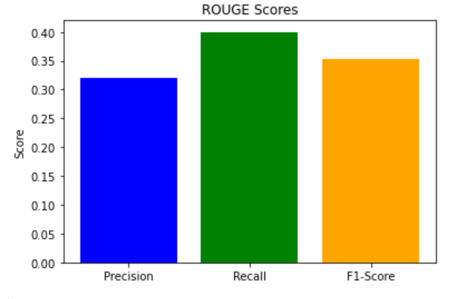
Fig.5 Rouge Scores

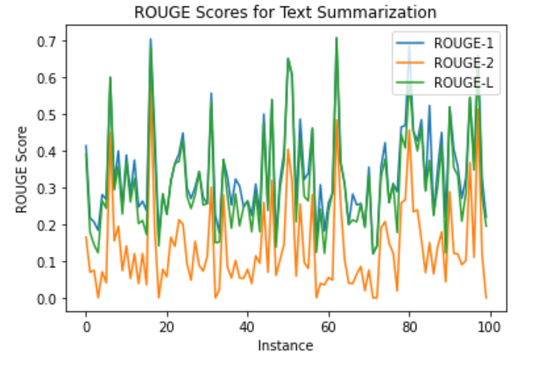
Fig.6 Rouge Scores for Summarization

The streamlit UI does this by combining a number of elements that make summarizing easier. Users have the option to upload documents in supported formats or type straight into a text field. After receiving the input, the T5 model and the streamlit application work together to process the data and provide the summary. Users may then examine and make use of the condensed material when the created summary is shown on the interface. There are several benefits of summarizing using streamlit UI. In order to interact with the model, users no longer need to possess technical skills; instead, it provides a smooth and interactive experience. Users don't need to deal with complicated coding or settings to just submit their text or files and receive summaries. Second, since users can swiftly utilize the summarized material and obtain instant results, the real-time production of summaries improves productivity.

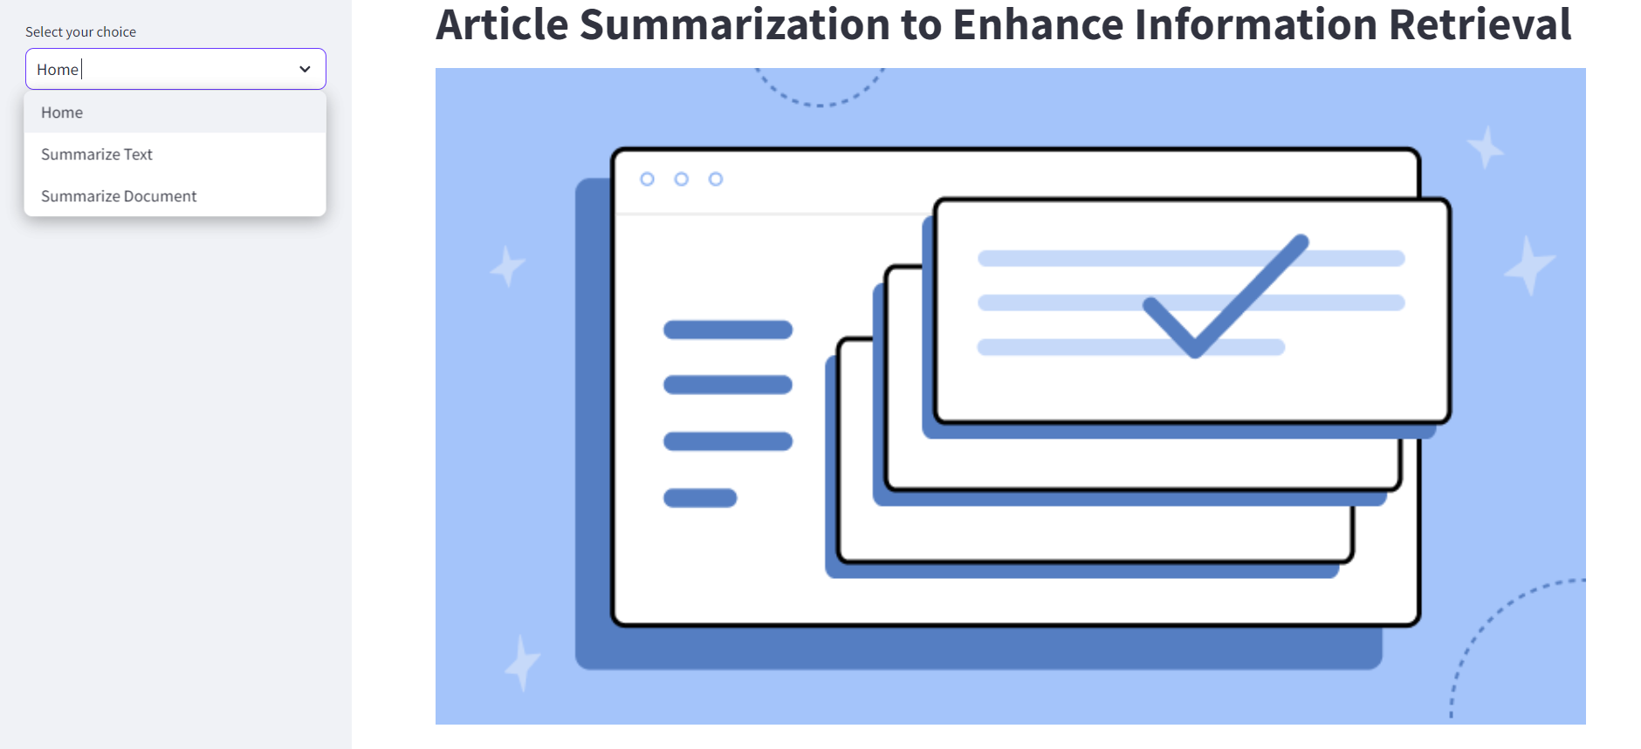
Fig.7 User Interface

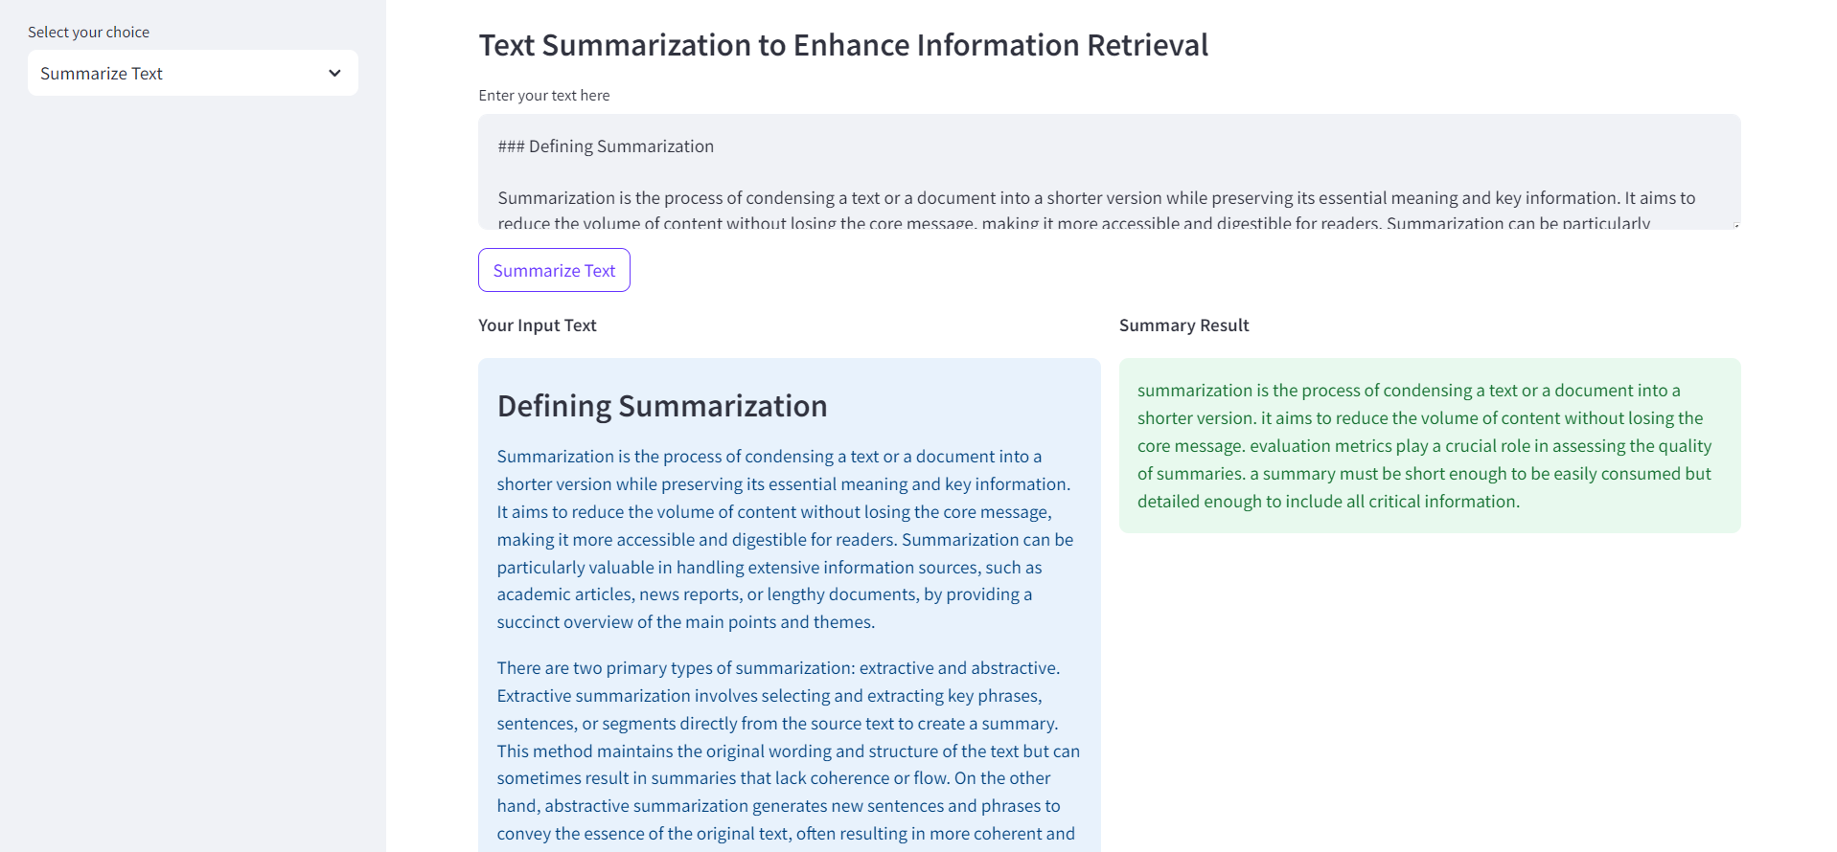
Fig.8 Summarization of Text & Article

Text input forms, file upload choices, and summary display sections are just a few of the UI design's components that are made to be user-friendly and accessible. The T5 model's connection with streamlit makes it possible to handle huge texts and documents quickly (as shown in Fig.7 & 8), which makes it appropriate for a variety of uses, including corporate reporting and academic research. This configuration guarantees that customers may take advantage of cutting-edge summarizing technologies in a useful and intuitive way. Additionally, scalability and customization are made easier with the streamlit UI. Users may customize the output to meet their own needs by changing factors like the amount of data and summary length. The interface is adaptable for a range of use cases as it can handle several document formats. This adaptability improves the summarizing tool's usefulness by meeting various user needs and settings. The ability of AI-powered summary tools to enhance information retrieval, expedite content analysis, and enable a variety of applications across many areas is highlighted by the marriage of sophisticated NLP approaches with user-friendly interfaces. The effectiveness of this strategy emphasizes how important it is to combine state-of-the-art artificial intelligence models with useful and approachable tools for improved productivity and user experience.

CONCLUSION
The work's conclusion emphasizes the T5 model's successful application and assessment for automated text summarizing, demonstrating how well it generates high-quality summaries for a variety of text and document kinds. The strong performance indicators, such as the remarkable ROUGE and BLEU scores, confirm that the model can generate useful, well-organized summaries that closely resemble outputs produced by humans. Users may now enter text or documents and obtain real-time summaries thanks to the practical and user-friendly approach to text summarizing illustrated by the integration of the T5 model with the streamlit UI. The potential of AI-powered summarizing tools to improve information retrieval, expedite content analysis, and offer insightful information across a range of applications is highlighted by this combination of sophisticated NLP algorithms with an easy-to-use interface. The project serves as an example of how using state-of-the-art machine learning technology may enhance text processing jobs, providing notable advantages in terms of effectiveness, precision, and usability.

References

- Kupiec, Julian, Jan Pedersen, and Francine Chen. "A trainable document summarizer." Proceedings of the 18th annual international ACM SIGIR conference on Research and development in information retrieval. 1995.
- Harley, Trevor A. The psychology of language: From data to theory. Psychology press, 2013.
- Mastropaolo, Antonio, et al. "Studying the usage of text-to-text transfer transformer to support code-related tasks." 2021 IEEE/ACM 43rd International Conference on Software Engineering (ICSE). IEEE, 2021.
- Yang, An, et al. "Adaptations of ROUGE and BLEU to better evaluate machine reading comprehension task." arXiv preprint arXiv:1806.03578 (2018).
- Mani, Inderjeet, and Mark T. Maybury, eds. Advances in automatic text summarization. MIT press, 1999.
- Agirre, Eneko, et al. "Two graph-based algorithms for state-of-the-art WSD." Proceedings of the 2006 Conference on Empirical Methods in Natural Language Processing. 2006.
- Day, Min-Yuh, and Chao-Yu Chen. "Artificial intelligence for automatic text summarization." 2018 IEEE International Conference on Information Reuse and Integration (IRI). IEEE, 2018.
- Narayan, Shashi, Shay B. Cohen, and Mirella Lapata. "What is this article about? Extreme summarization with topic-aware convolutional neural networks." Journal of Artificial Intelligence Research 66 (2019): 243-278.
- Butler, Daniel J., et al. "A naturalistic open source movie for optical flow evaluation." Computer Vision–ECCV 2012: 12th European Conference on Computer Vision, Florence, Italy, October 7-13, 2012, Proceedings, Part VI 12. Springer Berlin Heidelberg, 2012.
- Sekaran, Kaushik, et al. "Design of optimal search engine using text summarization through artificial intelligence techniques." TELKOMNIKA (Telecommunication Computing Electronics and Control) 18.3 (2020): 1268-1274.
- Afantenos, Stergos, Vangelis Karkaletsis, and Panagiotis Stamatopoulos. "Summarization from medical documents: a survey." Artificial intelligence in medicine 33.2 (2005): 157-177.
- Raskob, Wolfgang, et al. "User friendly application of RODOS." Radioprotection 45.5 (2010): S171-S179.
- Neto, Joel Larocca, Alex A. Freitas, and Celso AA Kaestner. "Automatic text summarization using a machine learning approach." Advances in Artificial Intelligence: 16th Brazilian Symposium on Artificial Intelligence, SBIA 2002 Porto de Galinhas/Recife, Brazil, November 11–14, 2002 Proceedings 16. Springer Berlin Heidelberg, 2002.
- Ma, Jun, Tong Li, and Yanling Zhang. "AI‐based abstractive text summarization towards AIoT and edge computing." Internet Technology Letters 6.5 (2023): e354.
- García, Salvador, et al. "Big data preprocessing: methods and prospects." Big data analytics 1 (2016): 1-22.
- Toman, Michal, Roman Tesar, and Karel Jezek. "Influence of word normalization on text classification." Proceedings of InSciT 4.354-358 (2006): 9.
- ABDULLAYEVA, Oqila. "THE PROCESS OF LEMMATIZATION, STEMMING AND TOKENIZATION IN CORPUS LINGUISTICS."
- Korenius, Tuomo, et al. "Stemming and lemmatization in the clustering of finnish text documents." Proceedings of the thirteenth ACM international conference on Information and knowledge management. 2004.
- Mastropaolo, Antonio, et al. "Studying the usage of text-to-text transfer transformer to support code-related tasks." 2021 IEEE/ACM 43rd International Conference on Software Engineering (ICSE). IEEE, 2021.
- Guo, Mandy, et al. "LongT5: Efficient text-to-text transformer for long sequences." arXiv preprint arXiv:2112.07916 (2021).

